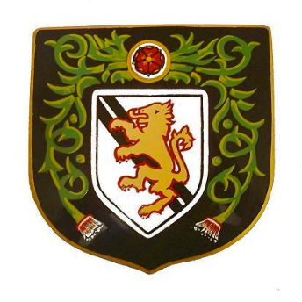

DIDSBURY CC JUNIORS
TRAINING DAY EVERY TUESDAY
TEAM | TRAINING TIMES - TUESDAY | MATCH DAY & START TIME | MANAGER & CONTACT
Under 10’S | 5 to 7 pm | W/C Basis | TBA
Under 11’s | 5 to 7 pm | Sundays. 10 am | Barry Ramsden-barryramsden.1@gmail.com  Paul Noble  Paul.Noble@dnvgl.com
Bulls | 5 to 7 pm | Fridays. 6 pm | Chris Ward  chrisward65@me.com
Buffalo’s | 5 to 7 pm | Fridays. 6 pm | Steve Morris  steve.morris@dwf.co.uk
Under 14’s | 6 to 8 pm | W/C Basis | Mike Schofield  mic.cor@ntlworld.com
Under 15’s | 6 to 8 pm | Sundays. 09:30 | Mike Schofield  mic.cor@ntlworld.com

COST
£80 FOR EACH PLAYER. £10 DISCOUNT FOR EACH SIBLING

